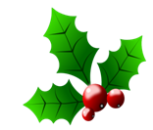 CHRISTMAS SPECIALS 2018
Package 1. Customised 45 minute facial including an intensive eye revitaliser treatment and a 15 minute soothing foot massage plus spa entry.
$130 per person

Package 2. A restful 30 minute back massage and 45 minute full body aqua salt scrub ending with a 15 minute stress releasing scalp treatment plus
spa entry. $175 per person

Package 3. Express 15 minute dry body brush and 45 minute blissful hot stone massage flowing into a 30 minute warm seaweed back radiance masque plus spa entry.
$190 per person

